

Progress Report 6
Ryan Schader
Name:
Project Title:
RISC-V RV32I CPU on an FPGA

Tell us about last week’s goals. How did they go?

To get all of the possible points for this section, write at least three sentences for each goal. Describe what each goal was and how you accomplished it (or what happened to prevent you from accomplishing it).

Goal #1: Extend reset coverage
I added four reset cases at instruction fetch and load request/response boundaries on October 23. All cases pass, with requests and writeback suppressed during reset, restart at PC zero, and x8 cleared. I saved assertion logs, GHW/VCD traces and a waveform; these results supplement the October 16 through 22 reporting week.
Status: ☒ Complete ☐ Partially Complete ☐ No Progress

Goal #2: Add a mixed RAM program
I added a five-iteration program combining arithmetic, a backward branch, and RAM stores and loads on October 23. The independent reference checks all 41 retirements and 15 data requests, then reads back the five expected sums 1, 3, 6, 10 and 15. The full regression passes 11 benches and 14 directed programs.
Status: ☒ Complete ☐ Partially Complete ☐ No Progress

Goal #3: Build the current JTAG design
I checked the current JTAG build prerequisites, but quartus_sh is unavailable in this environment. The saved preflight records the missing executable, so Intel IP generation, fit, timing and a fresh SOF remain pending. I carried this goal forward and made a successful current build the prerequisite for DE10-Lite testing.
Status: ☐ Complete ☒ Partially Complete ☐ No Progress

Set three goals to work on next week.

Progress reports are individual assignments. That means you will be setting goals that you yourself intend to accomplish this week. Be specific; set goals that can be completed in one or two weeks.
As you work on your goals, make sure to take at least one picture or screenshot to show what you have done. The picture or screenshot will need to be submitted in your next progress report.
To get all of the possible points for this section, write at least three sentences for each goal. Describe what the goal is and how you plan to accomplish it.

Goal #1: Build and validate the current JTAG design
I will generate the Intel JTAG UART IP and compile the current loader design by October 26. I will inspect fit, memory use, constraints and setup/hold timing at 50 MHz. I will archive tool versions, build reports and the SOF hash, or record the exact blocker before moving to hardware.

Goal #2: Test the CPU on the DE10-Lite
I will test the CPU on the DE10-Lite by October 30 after the current build passes. I will program through USB-Blaster, upload and run hello.bin, then check its message, EXIT 0000002A, return to ready>, rerun and KEY(0) reset recovery. I will save a board photo and the complete JTAG console log.

Goal #3: Verify a second uploaded assembly application
I will turn the mixed loop into a second uploadable assembly application by November 6. I will check its RAM results and return value in simulation, then upload it without rebuilding the FPGA. I will compare the board output with expected values and add the procedure and evidence to the user guide.

Visual Communication

Each report must be accompanied by an updated schedule in the form of a Gantt chart. You need to include the version from the previous progress report and the updated chart for next week. Paste them below or save the charts as pdfs and upload them separately.

Each report must also be accompanied by evidence of your work. This can be a photo, screenshot, graph, chart, code snippet, data table, or any other visual evidence that we discuss in class. Paste it below or upload it as a separate file.
Progress Report 6 schedule and results
Reporting period October 16 through October 22 2026, with a verification supplement completed October 23. The reset and mixed-program goals are complete as of the supplement. The JTAG build is partially complete because the tool preflight is blocked; current FPGA and physical board validation remain pending.
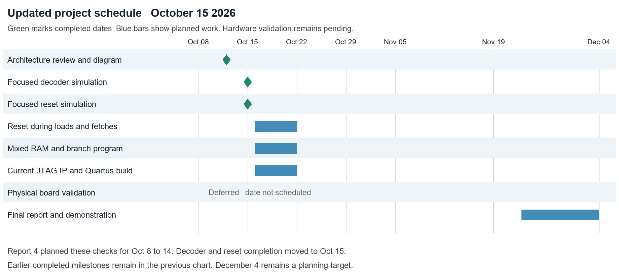
Previous schedule from Report 5, preserved as submitted. The reset, mixed-program and JTAG build targets were October 22.
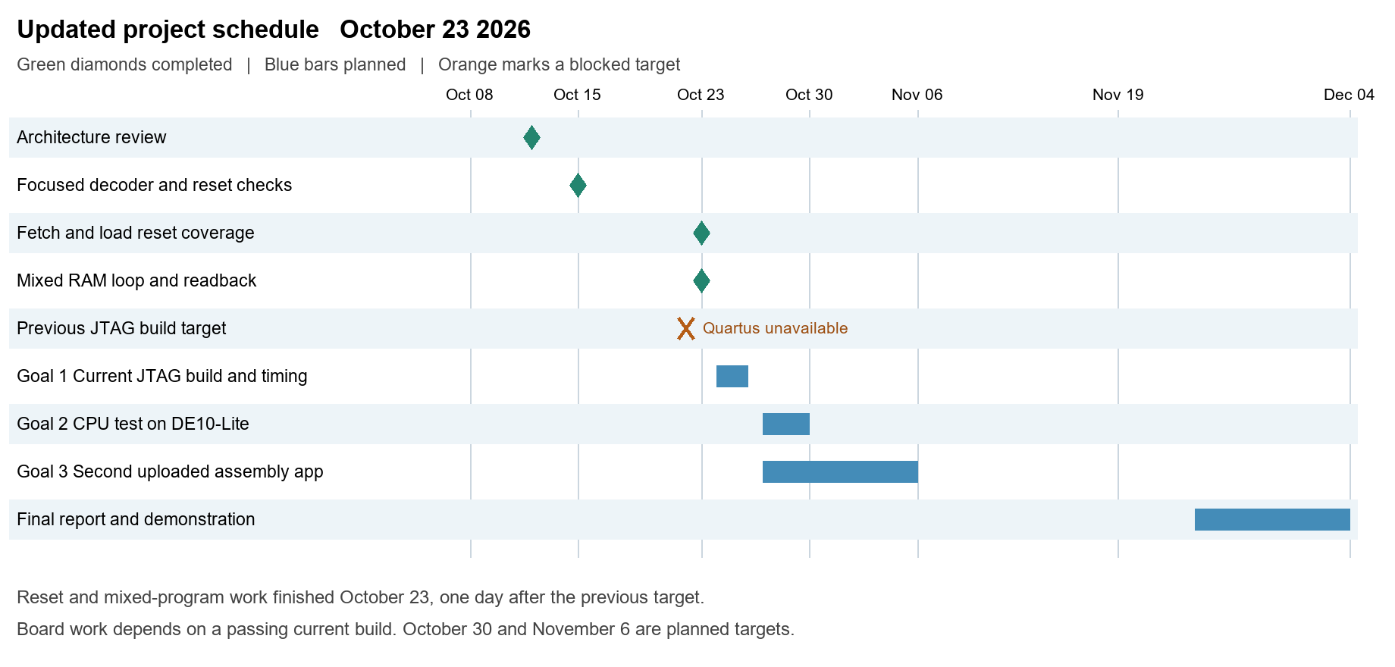
Updated schedule. Simulation work completed October 23. The carried build target is October 26; board testing targets October 30 and the second uploaded application targets November 6, subject to hardware readiness.
Reset coverage at fetch and load boundaries
The new tb_core_reset_extended uses the real CPU, register file, memory bus and RAM with an independent instruction ROM. Four injected resets check fetch before acceptance, fetch response, load before acceptance and load response. All assertions pass; simulation finishes at 2195 ns.
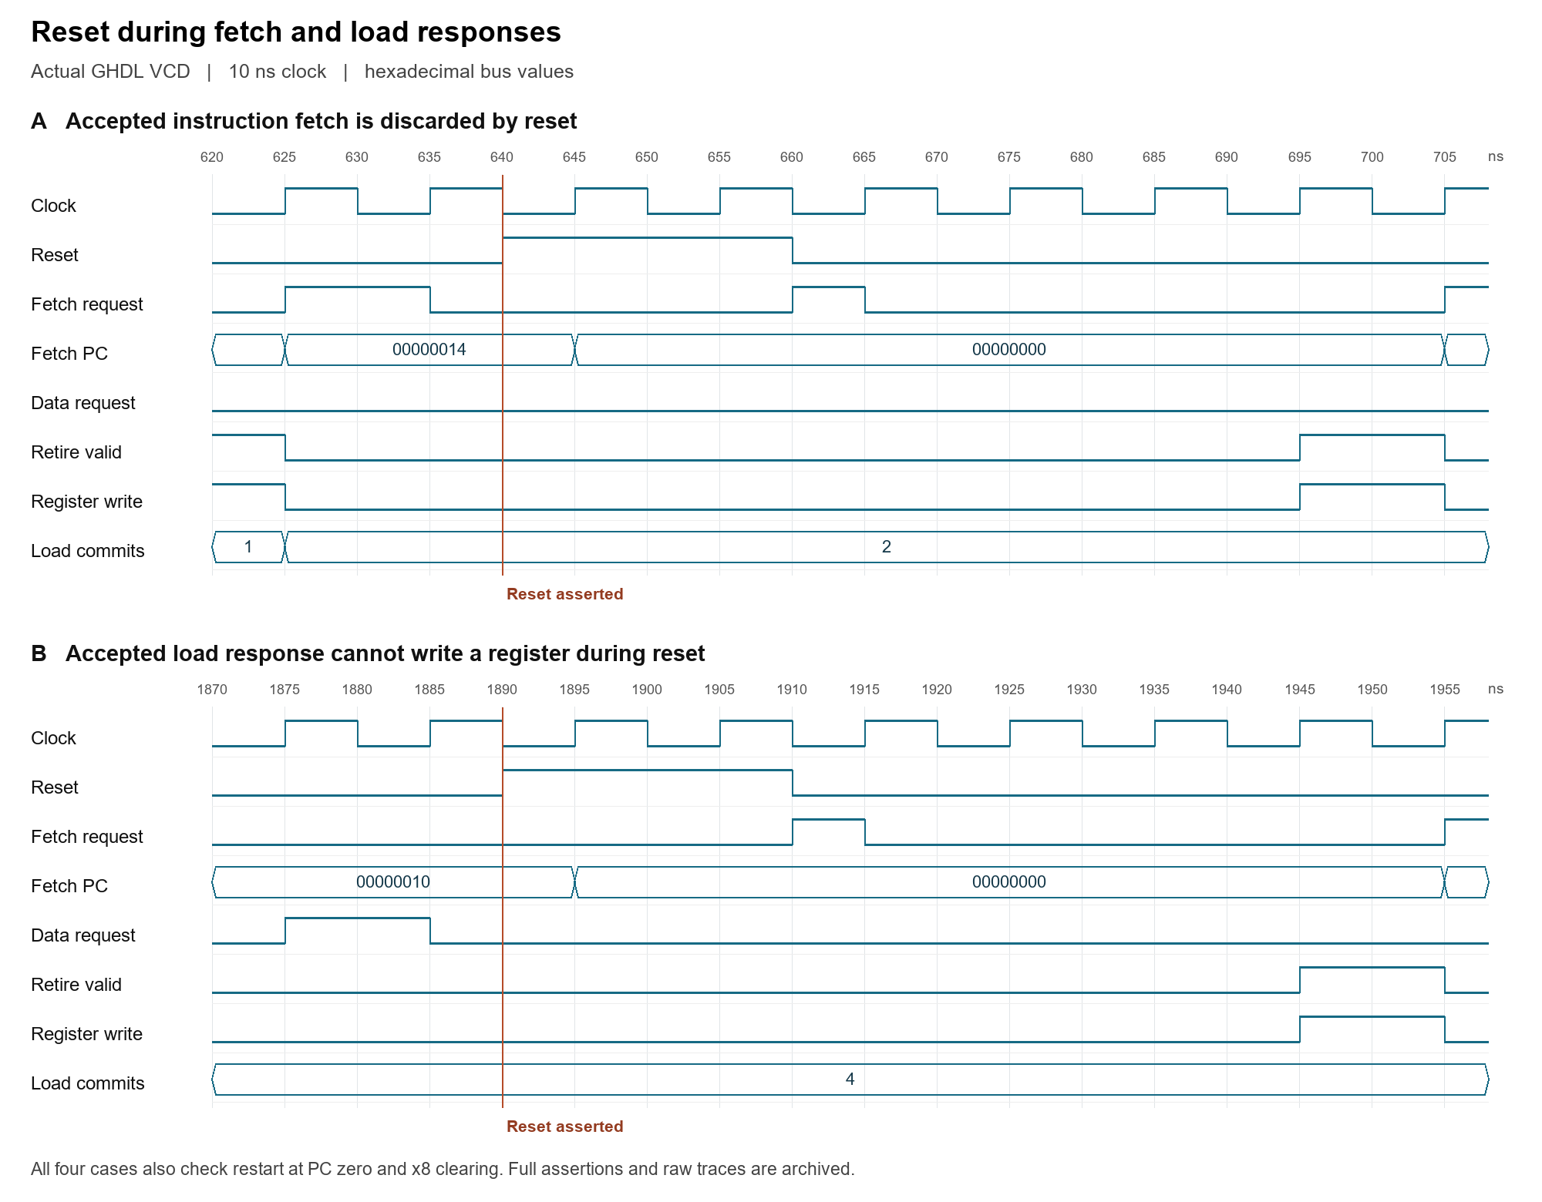
Figure 1. Actual saved VCD transitions around the fetch and load response cases. Reset gates both request and commit outputs before the next rising edge; the next fetch begins at address zero.
The test first loads 0x55 into x8. After each reset, ADDI x9,x8,1 returns 1, demonstrating that the register was cleared. Retirement and load-commit counters remain unchanged while reset is held, and a fresh load returns 0x55 after recovery. This extends the earlier three store/writeback cases; it does not establish reset coverage in every state or physical button timing.
Source: sim/tb_core_reset_extended.vhd. Evidence: report-6-reset-simulation.txt, report-6-reset.ghw, report-6-reset.vcd and report-6-reset-waveform.png in docs/progress_reports/evidence. Reproduce with scripts/report6_evidence.py.
Mixed RAM program and JTAG build status
The new mixed_ram_loop program sums 1 through 5. Each iteration adds the counter, stores the running sum, loads it back, advances the pointer and takes a backward BNE until the limit is reached. Fixed expected values are generated independently of the RTL decoder and ALU.
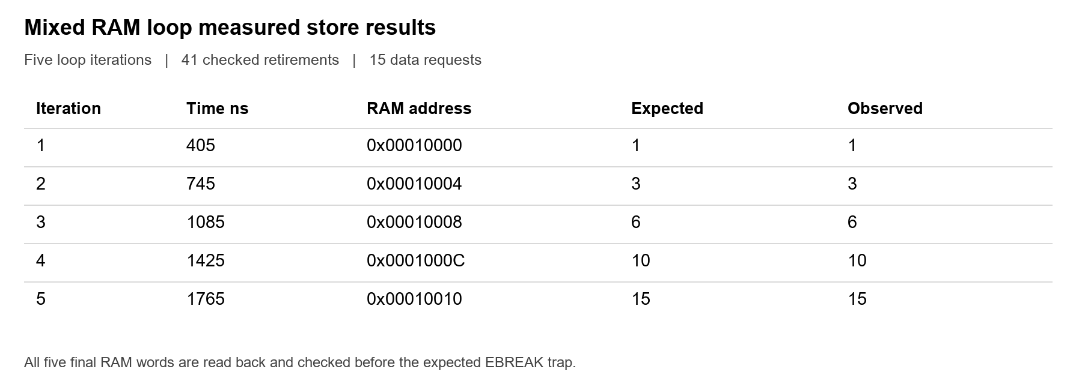
Figure 2. Store addresses, acceptance times and values extracted from the actual GHDL VCD. Five final loads also verify all stored words before the expected EBREAK trap.
The checker matches every retired PC, instruction, destination and result, with 41 retirements and 15 data requests. Four backward branches are taken and the fifth falls through. The full suite passes 11 fixed benches, 14 directed programs and five host protocol tests; local architectural adapter pass/fail/trap/timeout checks also pass. Existing time-zero numeric_std settling warnings remain. No upstream architectural certification is claimed.
Current JTAG build remains pending
The October 23 quartus_sh --version preflight failed because the executable was not available. No current Intel IP generation, Quartus fit/timing result or fresh SOF is recorded. The older GPIO build and the simulated Avalon/FIFO model do not validate physical JTAG operation. The next build goal must pass before programming the DE10-Lite.
The October 21 user guide documents setup, programming, upload and recovery, but is procedural evidence rather than a board-test result. The planned hardware check will record the loader banner, hello message, EXIT 0000002A, return prompt, rerun and KEY(0) recovery, together with the tested SOF hash and a board photo.
Evidence: report-6-regression.txt, report-6-host-tests.txt, report-6-adapter.txt, report-6-mixed-simulation.txt, report-6-mixed.trace, report-6-mixed-stores.json and report-6-quartus-preflight.txt. Sources: scripts/test_execution.py, sim/tb_program.vhd, docs/bringup.md and docs/user_guide/rv32i_user_guide.docx.

